Lab 07: Naive Bayes and Random Forest
Learning Objectives
- Naïve Bayes Classifier.
- Random Forest for Classification.
- Random Forest for Regression.

- Naive Bayes Classifier
Naive Bayes is a family of simple "probabilistic classifiers" based on applying Bayes' theorem with strong (naive) independence assumptions between the features. It is a classification technique based on Bayes' Theorem with an assumption of independence among predictors. In simple terms, a Naive Bayes classifier assumes that the presence of a particular feature in a class is unrelated to the presence of any other feature.
  - Classifier:
A classifier is a machine learning model that is used to discriminate different objects based on certain features.
  - Principle of Naive Bayes Classifier:
A Naive Bayes classifier is a probabilistic machine learning model that’s used for classification task. The crux of the classifier is based on the Bayes theorem.

Bayes Theorem:

Using Bayes theorem, we can find the probability of A happening, given that B has occurred. Here, B is the evidence and A is the hypothesis. The assumption made here is that the predictors/features are independent. That is presence of one particular feature does not affect the other. Hence it is called naive.
In simple words, Bayes theorem provides a way of calculating posterior probability P(c|x) from P(c), P(x) and P(x|c). Let’s look at the equation below:

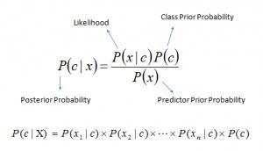

In the above equation:

- P(c|x) is the posterior probability of class (c, target) given predictor (x, attributes).
- P(c) is the prior probability of class.
- P(x|c) is the likelihood which is the probability of predictor given class.
- P(x) is the prior probability of predictor.

  - Working of Naïve Bayes’ Classifier:

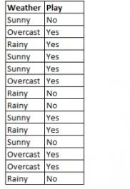
Let’s understand the working of Naïve Bayes’ classifier with the following example.

Here we have a training dataset of weather and corresponding target variable “Play” which suggests the possibility of playing. Now, our goal is to classify whether players will play or not based on the weather conditions. Naïve Bayes’ follow the following below steps to classify it:
- Convert the given dataset into a frequency table. Frequency table for the weather conditions is:
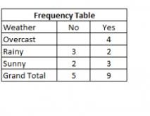

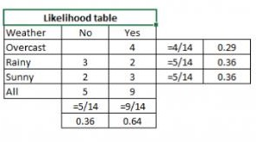
- Create Likelihood table by finding the probabilities like Overcast probability = 0.29 and probability of playing is 0.64.
- Now, use Naive Bayesian equation to calculate the posterior probability for each class. The class with the highest posterior probability is the outcome of prediction. Applying Bayes’ theorem:
Problem: Players will play if weather is sunny. Is this statement is correct?

P(Yes|Sunny) = P(Sunny|Yes)*P(Yes)/P(Sunny)
Here we have P (Sunny |Yes) = 3/9 = 0.33, P(Sunny) = 5/14 = 0.36, P(Yes)= 9/14 = 0.64 So, P (Yes | Sunny) = 0.33 * 0.64 / 0.36 = 0.60, which has higher probability.

P(No|Sunny)= P(Sunny|No)*P(No)/P(Sunny)
Here we have P(Sunny|NO)= 2/5=0.4, P(No)= 0.36, P(Sunny)= 0.36, which has lower probability. So P(No|Sunny)= 0.4*0.36/0.36 = 0.40

So, as we can see from the above calculation that
P(Yes|Sunny)>P(No|Sunny)

Hence on a Sunny day, Player can play the game.

- Random Forest
Random forest is a supervised learning algorithm. It has two variations – one is used for classification problems and other is used for regression problems. It is one of the most flexible and easy to use algorithm. It creates decision trees on the given data samples, gets prediction from each tree and selects the best solution by means of voting. It is also a pretty good indicator of feature importance.
Random forest algorithm combines multiple decision-trees, resulting in a forest of trees, hence the name Random Forest. In the random forest classifier, the higher the number of trees in the forest results in higher accuracy.
  - Random Forest algorithm intuition
Random forest algorithm intuition can be divided into two stages.
In the first stage, we randomly select “k” features out of total m features and build the random forest. In the first stage, we proceed as follows:-
- Randomly select k features from a total of m features where k < m.
- Among the k features, calculate the node d using the best split point.
- Split the node into daughter nodes using the best split.
- Repeat 1 to 3 steps until l number of nodes has been reached.
- Build forest by repeating steps 1 to 4 for n number of times to create n number of trees.
In the second stage, we make predictions using the trained random forest algorithm.
- We take the test features and use the rules of each randomly created decision tree to predict the outcome and stores the predicted outcome.
- Then, we calculate the votes for each predicted target.
- Finally, we consider the high voted predicted target as the final prediction from the random forest algorithm.
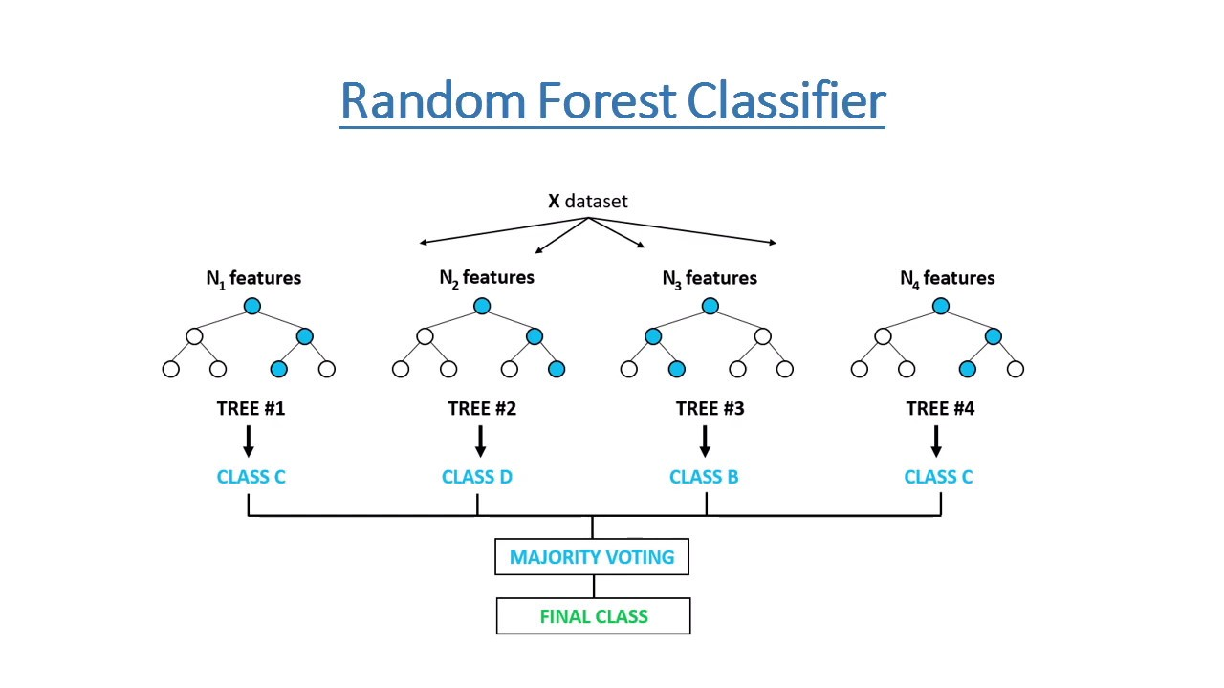
  - Pseudo Code for Classification
- Load the dataset.
- Split dataset into train and test set of ratio 70 and 30 respectively.
- Import random forest classifier from sklearn: from sklearn.ensemble import RandomForestClassifier
- Prepare the random forest classifier with parameter n_estimators=100.
- Train the model on iris dataset.
- One model is trained, calculate the accuracy, precision, recall and F1-score of the model.

  - Regression
In statistical modeling, regression analysis is a set of statistical processes for estimating the relationships between a dependent variable (often called the 'outcome' or 'response' variable, or a 'label' in machine learning parlance) and one or more independent variables (often called 'predictors', 'covariates', 'explanatory variables' or 'features').

    - Pseudo Code
- Load the dataset.
- Prepare the dataset: Separate the load dataset into dependent (Revenue) and independent (Temperature) variables.
- Split the dataset into train and test set of ratio 75% and 25% respectively.
- Import random forest regressor from sklearn: from sklearn.ensemble import RandomForestRegressor
- Prepare the random forest regressor with n_estimators = 10 and random_state = 0 parameters.
- Fit the model with reshaped train dataset.
- Predict the model with reshaped test dataset.
- Plot the random forest regressor results

Lab Tasks:

- Implement Naïve Bayes’ Classifier on the SMS Spam Collection Dataset. The dataset contains the Collection of SMS messages tagged as spam or legitimate.
- The dataset is provided on Google classroom. You can use from GCR or download dataset form kaggle https://www.kaggle.com/datasets/uciml/sms-spam-collection-dataset
  - Apply the required preprocessing steps on the dataset.
  - Calculate the TP, TN, FP and FP of the model and plot the confusion matrix.
  - Calculate the overall Accuracy, Precision, and Recall of the model.

- Apply random forest classifier on following dataset.
- Download car evaluation dataset form kaggle:
https://www.kaggle.com/datasets/elikplim/car-evaluation-data-set
- Do feature engineering for this dataset.
- Apply random forest classifier on this dataset.
- Evaluate the model performance and interpret in words what Evaluation metrics have revealed about the Model.

Lab # 07 Marks distribution

 | ER1 | ER5 | ER8
Task | 3 points | 3 points | 4 points

Lab # 07 Rubric Evaluation Guideline:
# | Qualities & Criteria | 0 < Poor <= 1 | 1 < Satisfactory <= 2 | 2 < Excellent <=3
ER1 | Task Completion | Minimal or no program functionality was achieved. | Some tasks were completed, but the program has errors or incomplete functionalities. | All tasks were completed, and the program runs without errors.
# | Qualities & Criteria | 0 < Poor <= 1 | 1 < Satisfactory <= 2 | 2 < Excellent <=3
ER5 | Analysis of Results | No attempt to analyze or interpret the results | Some analysis of the results is attempted, but explanations may be unclear or incomplete. | Results are correctly analyzed and compared to expectations, with clear explanations.
# | Qualities & Criteria | 0 < Poor <= 1 | 1.5 < Satisfactory <= 2.5 | 2.5 < Excellent <= 4
ER8 | Question & Answer | Answers some questions but not confidently or based on lab task knowledge. | Answers most questions confidently and based on lab task knowledge. | Answers all questions confidently and demonstrates a deep understanding of the given lab task.

